**Honours Project Report**

**A Web Application Chatbot teaching Nigerian Tribal Languages**

A report submitted as part of the requirements for the degree of BSc (Hons) in Computing Application Software Development

At

The Robert Gordon University, Aberdeen, Scotland

**Declaration**

A form declaring the original authorship of the content of the report should follow the title page. Sample declaration:

**Declaration**

**I confirm that the work contained in this Honours project report has been composed solely by myself and has not been accepted in any previous application for a degree. All sources of information have been specifically acknowledged and all verbatim extracts are distinguished by quotation marks.**

Signed: D.Akiode……………………….. Date: 03/05/2021……………………………

Honours Project: A Web Application Chatbot teaching Nigerian Tribal Languages

Robert Gordon university | [Company address]

Honours project

Daniel Akiode

2021

Table of Contents

1. Introduction: Why is this project important 5

1.1 Aims and Objections. 5

1.2 Report Structure 6

2 Literature Review 7

2.1 Existing Research 7

2.2.1 Can languages be taught through smartphones? 7

2.2.1.1 Mobile Assisted Language Learning (MALL) 7

2.2.1.2 Computer Assisted Language Learning (CALL) 7

2.2.2 Learning approaches 7

2.2.2.1 Reading Approach 7

2.2.2.2 Audio-Lingual Approach 8

2.2.2.3 Communicative Approach 8

2.2.2.4 Grammar-Translation Approach 8

2.2.2.5 Direct Approach 8

2.2.3 using chatbots. 8

2.2.3.1 What is a chatbot? 8

2.2.3.2 How do they work? 9

2.3. Technologies 9

2.3.1 Development Frameworks 9

2.3.1.1 Client-side development 9

2.3.1.2 Server-Side development 9

2.3.1.3 Database Solutions 10

2.3.2 Deployment 10

2.3.3 Methodology 10

2.3.3.1 Agile Development Methodology 10

2.3.3.2 Waterfall Development Method 11

2.3.3.3 Rapid Application Development 11

2.4. Existing Applications 12

2.4.1 Duolingo 12

-Functionality 12

-User Interface 12

-SWOT Analysis 13

2.4.2 Mondly 13

-Functionality 13

-User Interface 14

-SWOT Analysis 14

2.4.3 Memrise 15

-Functionality 15

-User Interface 15

-SWOT Analysis 15

2.4.4 Applications Summary 16

-Overview of the applications. 16

3 Design 17

3.1 Requirements Analysis 17

Functional Requirements 17

Must 17

Should 18

Could 18

Non-Functional Requirements 19

Must 19

Should 19

Could 19

3.2 Use Case Diagram 20

3.3 Data-Flow Diagram 21

3.4. Mock-Up User Interface 22

3.4.1. Colour Scheme 22

3.4.2. UI Design 23

4. Implementations 26

4.1. Front-End Development 26

Application Navigation 27

The Lessons and Quizzes 27

Building the Chatbot 28

4.2. Back-end development 28

4.3. Challenges 29

4.3.1. Approach to creating the chatbot. 29

4.3.2. Language Learning Approaches 29

5. Testing & Results 30

5.1. Acceptance testing 30

5.2. Chatbot Systems Testing 30

6. Evaluation 30

7. Conclusion 30

8. Appendix 31

Appendix A: Mock- Up User interface Design 31

Appendix B: Detailed Project Proposal 36

Defining your Project 36

Appendix C: Acceptance test table 46

Appendix D: Chatbot System Test 48

References 49

**Acknowledgments**

First and foremost, I would like to thank my parents for engineering the idea of building an application that teaches Nigerian Tribal Languages. I would also like to give a big thank you to my supervisor Stewart Massie for supporting me throughout this project.

# Introduction: Why is this project important

This project is involves designing and implementing a web application that teaches Nigerian and other African Languages. The web application will also contain a chatbot to communicate with the user only in in the target language, which would help the user get comfortable in speaking their new language and could use the chatbot as a practice for speaking the language in the real world.

This project is important because people with African decent can be a step closer to learning about their culture and people with non-African decent would get the opportunity of learning African Languages. Nigerian descendants and children who live in the United Kingdom or in the western world have little to no knowledge about their native language. The reason why they never been taught their native tongue is because when their parents immigrated to the United Kingdom or the United States, they would be forced to assimilate into English-Speaking culture to avoid being discriminated from job and resources and labelled “un-educated”. Therefore, the parents would not bother teaching their children their native language as they do not want them to go through the same turmoil they faced. (Spectra Speaks 2013) This is important for African descendants to learn their mother tongue because it defines their identity as human beings define themselves by the language they speak and would seem perplexing to identify yourself to a nationality or tribe when you do not speak their language. (Deyi, 2018) When kids grow an interest in learning their mother tongue, they would be being to embrace their culture in the process. The other reason for building this web application is to push teach African languages. West African Languages are not frequently learnt, discussed, or acknowledged worldwide compared to European and Asia. (Gibson, 2020) It seems surprising due to the fact that Africa is the most multilingual contentment in the world, with people speaking of 2000 languages, according to UNESCO. (Translators Associations Africa, 2021)

## Aims and Objections.

Aims:

* To build a web application and chatbot that teaches Nigerian and other African languages.
* To fulfil the requirements in Section 3.

Objections:

* Research how to build a web application and investigate the technologies required.
* Research how to build a Chabot.
* Learn an African Language and use the skills and knowledge into the application.

## Report Structure

**Literature Review:** An article that would discuss the practices of learning a language, existing applications that work with language learning and web technologies and development concept.

**Design:** Discusses the design, the interaction between users and client and the requirements analysis.

**Implementation**: This section will discuss and describe the construction of the application in detail from client-side to server-side.

**Test and Results**: Discusses how the application is tested and displays the test data to produce the results.

**Evaluation**: Discusses how well the project is developed and what needs to be improved.

**Conclusion**: Reflects on the project as a whole and discuss future developments.

# 

# 2 Literature Review

## 2.1 Existing Research

This section will be discussing if languages can be taught through smartphones, the approaches of learning a language and using chatbots.

## 2.2.1 Can languages be taught through smartphones?

Learning a language through a smartphone tends to be effective as a study has proven that 34 hours of Duolingo is equivalent to a whole semester at university. People would not have to use a language learning application to learn a new language as there are various ways to learn a language via a smartphone device. For example, people can learn a language by watching YouTube videos (how to tutorials) and watching films in their target language. They can also listen to music in the language they want to learn on Spotify or Apple Music.

### 2.2.1.1 Mobile Assisted Language Learning (MALL)

Mobile-assisted Language Learning (also known as MALL) is merely learning a language with the use of a smartphone or mobile device. Mobile learning (m-learning) has become a key attraction due to the popular demand of mobile smartphones in the modern world (Kukulska-Hulme 2020). For example, according to *finder* research has shown that 84% of the adults living in the United Kingdom own a smartphone in the year 2020. (Boyle, 2020) Just like a human teacher, Mobile learning can teach users how to read, write, speak and understand the language. M-learning can be both formal and informal as they can use mobile technology to learn in school or at home (Kukulska-Hulme 2020). With technology being accessible, M-learning builds an interactive-learning environment with various types of applications available on mobile devices. (Gafni, Biran Achituv and Joyce Rachmani, 2017)

### 2.2.1.2 Computer Assisted Language Learning (CALL)

Computer Assisted Language Learning (CALL) is when the user is learning a language through a desktop or a laptop. CALL was initialised in the 1980s where the filed was limited to only using desktop computers and basic software programs, until they evolved into using applications, blogs and online courses. (Gafni, Biran Achituv and Joyce Rachmani, 2017)

## 2.2.2 Learning approaches

The learning approaches are basically methods to learning a new language. It is important that the users know how they are going to approach learning a new language so that they can comfortably progress through the exercises using the approach of their choice. Section 2.2 is going to discuss five types of learning approaches: Reading, Audio-Lingual, Communicative, Grammar-Translation and Direct Approach.

### 2.2.2.1 Reading Approach

People who learn a language through the reading approach, are less likely to interact with other people in the language they have chosen to learn. They could choose the reading approach so that they can understand research papers or recipes that are written in a foreign language. (Stevie D. 2020) This approach can also be used to learn vocabulary. Which is important because understanding the words is the core of learning any language. (BLOG 2015)

### 2.2.2.2 Audio-Lingual Approach

This Audio-Lingual Approach would prompt and depends on the student to listen and repeat the words they hear on a radio or a recording in the target language. This would help the student pronounce the words properly. (Guarnera 2018) During the second world war, it was known as “The Army Method” as the military would need to learn the language of the allies and the axis. The method would then evolve in the 50s and the 60s. The approach is tackled by dividing a certain word into different sounds. For instance, if the audio asks the student to say ‘Hermano’ (Spanish for ‘brother’), they will break the word by the sounds and say “er” “ma” “no”. (Stevie D. 2020)

### 2.2.2.3 Communicative Approach

The Communicative Approach would assist the student to develop interactive skills in order to communicate with native speakers in the target language. The teacher is responsible for create opportunities for students to put that skill into practice. (Stevie D. 2020) Once the student has mastered the basic vocabulary, they can then begin to practice certain tasks related to a theme. (Guarnera 2018) For instance, the student can introduce themselves, talk about their hobbies and practice starting a conversation in the target language rather than solely having the language displayed to them. (Stevie D. 2020) Listening, reading, writing, and speaking are vital skills for these approaches (Guarnera 2018).

### 2.2.2.4 Grammar-Translation Approach

The Grammar-Translation Approach is the classic way of learning a new language, originally used to teach languages like Greek and Latin. (Stevie D. 2020) The approach is used to teach the student how to understand the grammar in their target language. A student could write a sentence in their first language and target language and figure out the grammatical difference. This approach would help with the reading and the writing. (Guarnera 2018)

### 2.2.2.5 Direct Approach

The Direct Approach is fundamentally the opposite of the Grammar-Translation Approach where it does not focus on grammar but focus on speaking the language. This type of approach would only be taught using the target language where listening, and comprehension skills would become extremely crucial. This would also mean that they will not be any need to revise the vocabulary. (Stevie D. 2020)

All five of the learning approaches are best for the project as they play a major role when it comes to mobile learning. In the project, the chatbot would use the communicative and direct approach and the activities in the web app would use the audio-lingual, reading and grammar-translation approach.

## 2.2.3 using chatbots.

Section 2.3 discusses the use of chatbots and how they work. The reason why chatbots are going to be used in the project is because they would be used to help the user practice having a conversation in the targeted language, so that they can feel confident when speaking the language in real-life. Other language learning apps like Duolingo and Memrise are known to use chatbot technology. (Blog.vsoftconsulting.com 2020)

### 2.2.3.1 What is a chatbot?

A chatbot is a piece of software application driven by Artificial Intelligence that mimics human speech to stimulate a conversation with a real human being via text. Chatbots are commonly used for customer service where the chatbot would communicate with the customer as if it were a living human being. Today, people can create their own chatbots without a degree or prior coding experience. (Shewan 2020)

### 2.2.3.2 How do they work?

Chatbots are developed using natural language processing or NLP. NLP is also the foundation of voice recognition systems which are known to be used by various virtual assistants such as Google Assistant, Apple’s Siri and Amazons’ Alexa. Before responding to the text that is sent by the user, the chatbot would then analyse the text by using a series of algorithms translate and understand what the user has said and figure out how it would respond. (Shewan 2020)

## 2.3. Technologies

## 2.3.1 Development Frameworks

A development framework is a platform that is used for implementing software applications and provides a foundation for software developers to build programs. Frames works may contain built-in functions and classes that are used to interact with the program. (Techterms 2013 ) *Django, Angular and Meteor* are the examples of the Web Application Development Frameworks. (Geeks 2020)

### 2.3.1.1 Client-side development

Client-side development is programming skills are used to create the structure of the website such as the user interface and the web pages (Home Page, Contact Page, Shopping Page etc). Ultimately, the Client-Side Developers is responsible for the visualisation and the functionality of the website. Client-side development is also known as **Front-End Development** as the work is presented in-front of the client. (Weinstein 2020) Languages like JavaScript, HTML and CSS are used for client-side development.

### 2.3.1.2 Server-Side development

Server-side Development involves the development of the backend of the website which involves data exchange (Weinstein 2020) and communication between the web server and the browser using *Hypertext Transfer Protocol* (HTTP). A HTTP request is transferred from the browser to the server every time the user click on a URL link or fills out a form online. Once the server has received the message from the client, it would respond to the browser with a HTTP response message. (MDN Web Docs 2020)

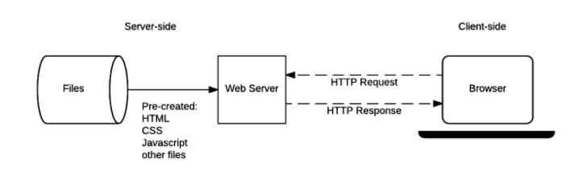

*Figure 1: Server-Side development diagram* (MDN Web Docs 2020)

### 2.3.1.3 Database Solutions

Databases are important if the developer wants to create an interactive website. Databases can be created by using Databases Software. Database Software is a utility or a program that allows users to create, edit and maintain database files and records. Database management systems allow users to organise their data into columns, fields and tables. *MySQL*, *Firebase* and *MongoDB* are examples of Database management systems. (Enfroy 2020)

## 2.3.2 Deployment

Software Deployment is a process when the developer delivers the software to the client of the consumers. It is idle that the deployment should take place after rigorous testing so that flaw and errors can be fixed. For web development, deployment means uploading the website onto a server where the final testing can be done before it is released to the public. (GoodFirms 2020)

## 2.3.3 Methodology

Methodology is a system of methods that allow project manager and development teams to tackle a project strategically. It is extremely vital for the development team to pick a methodology so that they can finish the project successfully. (Team 2017)

### 2.3.3.1 Agile Development Methodology

The Agile Development Methodology is mostly used to prevent problems that may arise during the development of the software such as errors, requirement changes and expenses. (Team 2017) The Agile methodology allows the development team to send increments to clients separately so that there is transparency and feedback from the client. The downside to the agile methodology is that it focuses more on developing the software and lacks documentation meaning that the development team is likely to lose track of what they are doing. (blogs 2020) 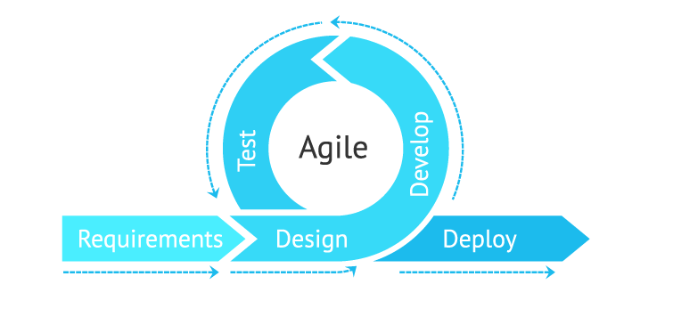

*Figure 2: Agile Development Methodology Diagram* (Hazevytch and Vilchynska 2020)

### 2.3.3.2 Waterfall Development Method

The waterfall method is also known as the traditional development method is well known which is a linear model that explains the process of software development in sequential levels: Requirement, Design, Implementation, Verification (Testing, Evaluation, Documentation) and Maintenance. When working with the waterfall method, the team must make sure that each level is 100% complete before moving into the next stage as going back to make changes will not be possible. The waterfall method is easy to understand the process of developing software. Novice software developers and managers are likely to capitalise from the waterfall method. However, the waterfall methodology tends to be tedious and expensive due to the inflexibility of the model. (Team 2017)

Figure 3: Waterfall Method Diagram (Santos 2020)

### 2.3.3.3 Rapid Application Development

The Rapid Application Development (RAD) method is a compressed process that forces the development team to develop a high-quality product within a short period of time and low investments. RAD is similar with the agile development method with RAD being more efficient to large companies as they tend to have numerous amounts of clients. (Team 2017) RAD allows the developing team to build multiple iterations and make changes to the software rapidly. Therefore, they do not have to start the project all over again. RAD came into effect after developers realised that the waterfall method is not efficient. (Kissflow 2020)

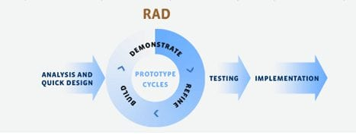

*Figure 4: RAD Diagram* (Singh 2019)

## 2.4. Existing Applications

Section 4 will discuss three of the applications three of the language learning applications that use chatbot technology (Duolingo, Mondly, Memrise) describing the functionality and create a SWOT analysis for each application.

## 2.4.1 Duolingo

## -Functionality

Duolingo provides a series of lessons with listening exercises, flash cards, and multiple-choice questions to help the users memories new words and phrases. Duolingo allows users to comment about most of the questions and create a thread so that users can then help each other understand and discuss any issues with the question. Users can create groups with other users who are learning the same language so that they can motivate each other. (Ravenscraft 2019) Duolingo has included podcasts about true stories for users learning French and Spanish so that it can help them with their listening comprehension. (Pajak and Tsai 2020) Duolingo’s chatbot uses AI algorithms to understand and respond to users. Hence why they would receive different responses. (Blog.vsoftconsulting.com 2020)

## -User Interface

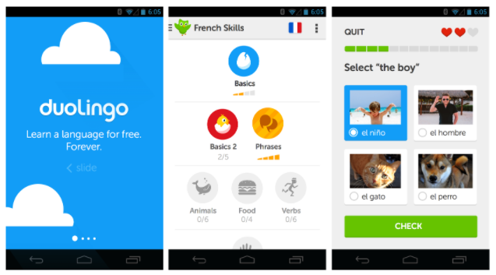

*Figure 5: Duolingo Interface* (Research Gate 2020)

## -SWOT Analysis

**Strength**

* Duolingo is free to use, unless the user decides to pay a premium (Duolingo Plus)
* Reports say that it is entertaining to use as it shows a “game-like” property.
* Duolingo gives the users a chance to correct all the questions they have gotten wrong.

**Weakness**

* Duolingo does not teach the user about the grammatic use of the language. (Papadopoulou 2014)
* Duolingo does teach the basics for beginners of the language and goes right into words meaning that only using Duolingo to learn a language would not be helpful. (Thompson 2020)

**Opportunities**

* The application teach users about the grammatic uses of the target language.
* Teach the users how to start a conversation in the target language.

**Threats**

* Lacks to provide the motivation to the users.
* Internet Access is a necessity.

## 2.4.2 Mondly

## -Functionality

With Mondly, users are allowed to pick multiple lessons every day that can help them strengthen their vocabulary and practice their speaking. The lessons provide can take the users up to 2 minutes to complete (Bahoosh 2020), teaching from 8 to 15 words and phrases. Users are able to choose if they are a beginner, intermediate or advanced learner. (Ceasar 2020) During the lessons the user would participate in various of activities such as dragging words to match the presented image, filling in the blank to complete a certain sentence and using the microphone built in the smartphone to practice their speaking. To prompt the users to stay motivated, the application would give the users three stars for every lesson. Every time the user makes a mistake, they would lose a star. What make Mondly stand out from the other language learning applications is that the application would use augmented reality (AR) to display a visual teacher in the real world with your front view camera. (Bahoosh 2020) Mondly’s chatbot would allow the users to type or speak their responses and helps them with real-life scenarios. (Blog.vsoftconsulting.com 2020)

## -User Interface

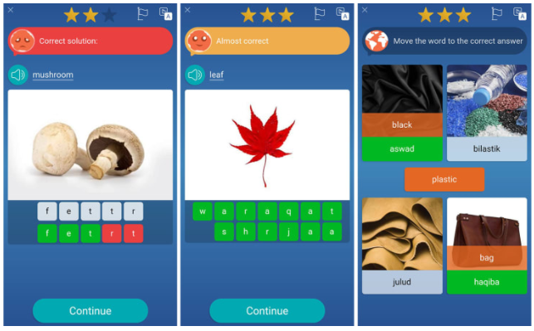

*Figure 6: Mondly Interface* (Bahoosh 2020)

## -SWOT Analysis

**Strengths**

* Teaches users how to converse in the target language.
* Provide quick lessons.
* Just like Memrise, it uses native speakers for all language available.

**Weakness**

* Free version of the app is limited.
* The app does not teach users grammar effectively.
* Mondly does not teach users the gender of the words.

**Opportunities**

* Reward the user for every successful lesson.

**Threats**

* Requires payment if the user want the full experience of the app. (Admin, 2020)

## 2.4.3 Memrise

## -Functionality

Memrise mainly uses flashcards to allows users to revise and memorise the new words they have just learnt. If they want, they users can upload and add mnemonic images in their flashcards. Memrise has arranged the course into courses or “decks”. The users would be able to review words they have seen before. (Sirk 2020) In Memrise, some of the courses are made by users teaching a variety of subject in the target language. If the user has chosen to use the application for free, then they can only learn and review the words. If they user has paid for Memrise Pro then they are entitled to the following features: Speed Review, Difficult Words, Listening Skill, meet the natives, grammarbot & chatbot and offline mode. (Kent 2017)

## -User Interface

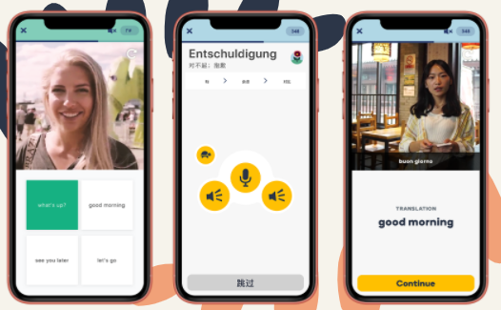

*Figure 7: Memrise Interface* (Sirk 2020)

## -SWOT Analysis

**Strengths**

* The user interface is user-friendly.
* The application uses video clips of the native speakers of the application making it feel like a real-life lesson.
* Just like Duolingo, the app is free to use.

**Weaknesses**

* Does not provide grammar lessons.
* Speaking practice is minimal.

(D. and Cristiano 2020)

**Opportunities**

* Teach user about the use of grammar.
* More speaking practice
* Add more activities.

**Threats**

* Premium features are said to be uninspiring.

## 

## 2.4.4 Applications Summary

## -Overview of the applications.

Duolingo, Mondly and Memrise were chosen to discuss as all three of them are known to use chatbot technology which would be incorporated in the project. All three of the application seem to lack teaching the user the grammar of the target language. For the project, we would capitalise on that weakness by making sure that the web app would teach the grammar of the chosen language to the user. All three of the applications are free of charge which is an advantage as it draws in more customers. If the users enjoy the application and want to try out exclusive features, then they can pay for a perineum membership.

# Design

## 3.1 Requirements Analysis

The requirements are written using the MoSCoW method that priorities the requirements into Must (Mo), Should (S), Could (Co). If the requirement is a “Must”, it means that the requirement has to be met in order to for fill the purpose of the application. If the requirement is prioritised as “Should”, then it means that the requirement is important, but it is not needed to for fill the purpose of the project. If the requirement is prioritised as “could”, it means that requirement is desirable but not important.

## Functional Requirements

### Must

1. Chatbot must communicate with the user in the language chosen by the user so that the user can practice the targeted language.
   1. Must communicate with the user in text format.
   2. Chatbot should be tested thoroughly.
   3. Users should interact with the chatbot in the language they have chosen and not I n another language. For example, when the user has chosen to speak Yoruba, but they should only interact with the chatbot speak Yoruba. This is the direct approach of learning a language. (Lit Review Section 2.2.5)
   4. Could communicate with the user with voice recognition.
   5. If the user completes a lesson successfully, then the user should get a chance to interact with the chatbot.
2. Must teach the user at least one language.
   1. Within one language, web application is required to provide lessons to the users to enhance their learning. Lessons will consist of questions that would ask the user what a particular word/sentence/phrase mean and ask how they are pronounced. The system would also ask they user to fill in the blanks of a sentence.
   2. Should teach the user basic vocabulary, grammar, and convocational skills since they are not taught in the popular language applications (Lit Review Section 4).
      1. Users should be able to view the vocabulary the have learnt so far.
   3. The language available must be Nigerian or African.
   4. Should display flash cards.
   5. Users should select a language they want to learn.
      1. Users should display a list of lessons.
      2. Users should be able see the lessons they have completed, and which lessons are available for them.
      3. Some lessons should be locked until the user is close to mastering the other lessons.

### Should

1. All users should register and create an account in order to use the application so that they can save their progress.
   1. Must include a login system and must be tested thoroughly.
   2. A secure database must be used to store the log in details.
2. Lessons should be more difficult than the previous lessons so that there is challenge for the user.
3. Should display an “about” page so that the user can have some clarity about how the website works.
4. Should contain 2 types of users: Admin User and Learning User
   1. Should allow Admin User to manage database.
   2. Should allow Admin User to manage and secure user login.
   3. Should allow Admin User to manage Learning User accounts
   4. Should allow Admin User and Learning Users to reset passwords.
   5. Learning Users and Admin Users should be able to display their profile displaying their personal information. (Username, Email, forename, surname, etc.)

### Could

1. Could Allow users to log-in via other account such as Facebook, Twitter, Google etc.
2. Could allow users to communicate so that they can help/compete against each other.
3. Could provide games and activities for users to provide entertainment and motive for the user to use the application again.
   1. Could provide a score and ranking system to increase motivation. For example, the user may gain a certain amount of points every time they get a question right or complete a level.

## Non-Functional Requirements

### Must

1. Web Application must use a Web Server.
   1. Should be accessible in both Desktop and Mobile devices.
   2. Users should be able to access the Web app in all web browsers.
2. Must use HTML, CSS, JavaScript, and PHP.
   1. HTML – Mark-up Language that is used to build web pages.
   2. CSS- Cascading Style Sheets that is used to design the web pages.
   3. JavaScript – Scripting Language that would be used make the website interactive.
   4. PHP - Server-side scripting that would be used to communicate to the server.
3. The system requires the internet in order to function.

### Should

1. Should use African colours for colour scheme – Red, yellow, and green.
   1. Could allow users to switch between light mode and dark mode.
2. Python/JavaScript/jQuery should be used to build Chatbot.
3. Should provide an instruction manual to help the user navigate through the navigation.
4. Should store user login details securely using MySQL or Firebase.
5. Should be fully functioning by 19th of April 2021.
6. Should aim to keep the budget to £0.

### Could

1. Web Application could be responsive – meaning that the information on the web pages would fit nicely on any device without any extra coding.

## Use Case Diagram

*Figure 8: Use-Case Diagram for the Web Application*

The use case diagram below illustrates how the application is going to be used, showing how the users, admin, the computer and the chatbot are going to interact with the system. In the diagram they would be represented as actors (The stickmen). The white ovals are called use cases. They determine the role of the actors. The lines connecting the use cases are called relationships that determine how the actors, and the use cases are going to behave when they connected. For example, the links between the New User, the Admin, and the User show that they are both inherited to the User, meaning that the admin and the New User can take the roles of their ancestor, in this case, the User. This is called a Generalisation. The links without the arrows between the Actors and the use case are called an Association. This is where the Actors are delegated to their roles in the system. The doted lines with the arrows are called includes. They connect uses two use cases, a base use case (Use case associated with Actor) and an include use case. The dotted include link means that the base use case cannot run unless the use case included it activated. The link with the white arrow are called extends which work just like an include but this time the second use cases connected are optional rather than mandatory like the includes, meaning that the base use case does not need the extended use case to be activated.

## Data-Flow Diagram

*Figure 9: Data-Flow Diagram for the Web Application*

The Data-flow diagram above, describes how the data is going to be transferred between events. Once the user apply their login details. The data would be sent to the data sent to the user database to verify and confirm the user account. The language options would be coming from the language database which would also send data to the vocabulary sheet. Once the use is on the main menu, they would have the option between viewing the vocabulary sheet, start a lesson or enter the chatroom to interact with the chatbot. When the user has started the lesson, the questions would be coming from the computer. Once the users is done with the lesson, there progress would be saved in the user storage.

## 3.4. Mock-Up User Interface

### 3.4.1. Colour Scheme

The colour scheme mostly consists of black, red, and green, with a white and yellow as secondary colours. The colours are inspired by the Pan-African flag created by late Jamaican Activist Marcus Garvey. The flag is used to represent and unify the African Diaspora (Black Student Center, 2021), which is a group of communities who are descendants of Native Africa or African people predominantly the United States (Currey, 1998). The African Diaspora is mostly described as the dispersion of the African people during the transatlantic slave trade between the 1500s and the 1800s, hence the name ‘Diaspora’.

Figure 10: Pan-African Flag (EVERETT, HARDICK and JOHNSON, 2021)

The red represents the blood of African Ancestry, the black represents the people of Africa, and the green represents the wealth and abundance of Africa. The vast majority of African countries use these colours to show solidarity. This flag is would likely appear in Black Activism and Black Organisations that are known to fighting injustice and racism. (Black Student Center, 2021)

Figure 10: Pan-African Flag Displayed in Protest 1 (ibw21, 2015)

Figure 11: Pan-African Flag Displayed in Protest 2 (Chamberlin, 2020)

### 3.4.2. UI Design

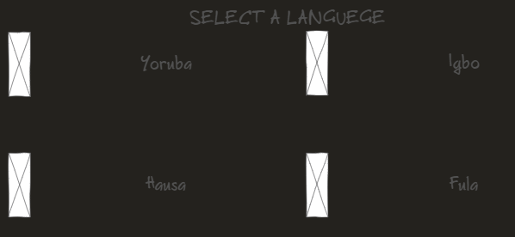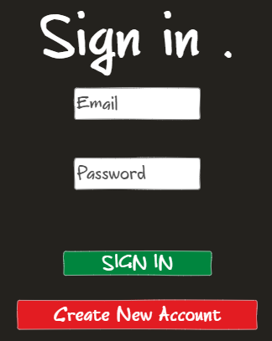The user interface would be used to allow the user to interact with the web application. When the use first opens the application, they are required to create an account and log in to their new account. Once the user has done that, they would be given various options of what Nigerian Languages to choose from, such as Yoruba, Igbo and Hausa.

Figure 13: Language Selection

Figure 12: Mock-up Sign in Form

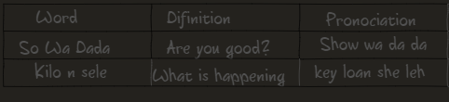After the user has chosen their language, the application would display a vocabulary sheet for the user to familiarise themselves before heading into the lessons. The vocabulary lesson would contain a table that would display the word or phrase in the chosen language, the translation in English and how it is pronounced.

Figure 14: Vocab Sheet

Once they have clicked on the green ‘Start Learning’ button, the application would lead them to a selection of lessons with the majority of them being locked until the user has successfully completed the previous lessons, in this case, lesson 1.

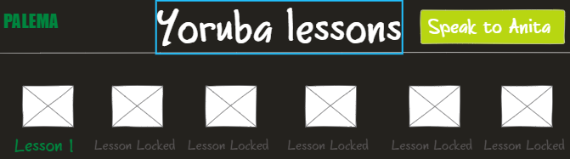

Figure 15: Lesson Selection

The gold button on the top right-hand side of the screen that says ‘Speak to Anita” would link the user to the chatroom where they can interact with Anita the chatbot only in the targeted language. Anita is an acronym for African, Notation, Intelligent, Teaching, Assistant. The reason why they are only using the target language instead of English is because it would help the users strengthen their new vocabulary and it would be good practice for when they begin to use the target language in real life conversations. This is called the Direct Approach of learning a new language. (See Section 2.1.2.5 to find out more)

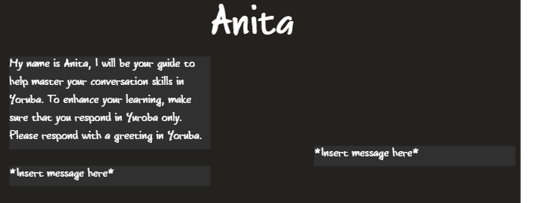

Figure 16: Mock-up Chatroom

When the user click on a lesson, the application would display a series of questions from 1 to 10, either multiple choice or in text form. If the user answers the question right, then green text would appear saying “Answer is Correct”. If the user answers the question wrong, then red text would appear saying “Incorrect, trying again”. Once the user has completed the lesson, the application would display a congratulations message giving them the option to either speak to the chatbot, proceed to the next lesson, or return to the main menu.

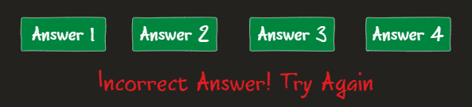

Figure 17: User Answers and red error message

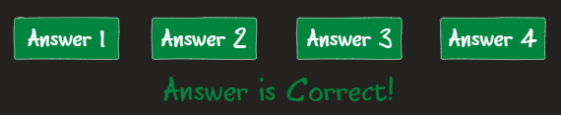

Figure 18: Multiple Choice Answers with green success message



Figure 19: Text Box for Answers

# 4. Implementations

This chapter will discuss the technologies and methods that were used to build the application. This chapter will also discuss the challenges that have been face during the development. The implementation involves using a web stack which is basically a group of technologies that are used to build an application which involves a web server, an operating system, a database, and a programming language. For building the web application, I have used the MERN web stack, which stands for **M**ongoDB, **E**xpress, **R**eact and **N**ode. All four of these technologies consist of using JavaScript only, despite using HTML and CSS being used in the front-end of the application. Node would be used instead of php even though the Requirements Analysis mentions that php must be used in the development. I have replaced is because, as mentioned earlier in this section, Node uses the same language as the other 3 technologies in the stack which saves me from switching back and forth between languages. MongoDB would be the database that would hold the user login details and the user-chatbot responses. Express would be used to help with the routing in the server-side between the server and the database. Node would be used to build the web server and React would be the framework that be used to build the user interface.

## 4.1. Front-End Development

The Front-End of the application deal with the User Interface and everything the user sees and interacts with. This is also known as the Client-Side of the application, which is where react would be utilised. Originally, I was planning on using normal HTML and CSS for the user interface, until I discovered react while working on another module in my course, which was more manageable than normal HTML despite the steep learning curve. Using React allows me to reuse code for different pages, instead of having to copy and paste the code for every time I want to create a new page, using components.

### Application Navigation

To initial the implementation, I would have to sort out the navigation of the application. I have started by building the components which would be presented as pages. Building a homepage first as the initial page for when the user opens the application. I would then create the main menu for the user to select between the lessons, enter the chatroom to speak to the chatbot and viewing the vocabulary sheet. Once the user has been through the quiz, they can either enter the chatroom to speak to the chatbot, go back to the menu or proceed to the next lesson. The application contains 8 function components.

**Chatbot.js:** Used for chatbot functionality.

**Quiz.js:** Used for lesson 1 functionality.

**Quiz2.js:** Used for lesson 2 functionality.

**MainMenu.js:** Used for displaying the application menu.

**VocabSheet.js:** Used for displaying the vocabulary table.

**Homepage.js:** Used as the start-up page.

**EndQuiz.js:** Used for displaying the points scored in lesson 1.

**EndQuiz2.js:** Used for displaying the points scored in lesson 2.

The application is built with React hooks which are functions in React that allows me to manipulate states and lifecycle features from components without using classes. Making the workflow quicker and the code more simplified. The react hook function useState() was is used to change between components when a specific component is called out. UseContext is used to branch the components together, so that they can share values without the use of props.

### The Lessons and Quizzes

For building lessons and quizes, I iinitally had to buld a dependacy .js file called “QuestionBank.js” which would store both the question and the answers respectivly. QuestionBank.js woyuld be importeed by the componenet Quiz.js, so that it can display the questions on the user interface and compare the answers to what the user has selected to make sure that the user is correct. If the user gets the answer right, then the application will reward them 1 point. Once the user is done with the lesson, the component “EndQuiz.js” would then display the how much the user has scored against how many questions thet answered. Quiz2.js and EndQuiz.js will have the same princple along with there own dependacy “QuestionBank2.js”. Lesson 1 contains 10 questions and Lesson 2 would contain 5 questions. All question are in mutiple choice.

### Building the Chatbot

For building the chatbot. The component “chatbot.js” would be used to deal with the functionality and the interactions with the user. The dependency file RESPONSEDATA.JSON would store response from the user to the chatbot. So far, the .json file holds up to 15 responses, but more would be added in future developments. Chatbot.js would import the .json file, so that it can be used to display the chatbot message and validate the userInput so that it matches the user response on the .json file. When the user types in a message on the input box and click send, if the user input is equal to the user response on the .json file, then the chatbot response message would be displayed. I used the JavaScript built in function toLowerCase() so that the input box is not case sensitive. The includes() method is used to determine whether the user input is in the .json file.

## 4.2. Back-end development

## 4.3. Challenges

### 4.3.1. Approach to creating the chatbot.

The most challenging part of implementing the application was figuring out how to build the chatbot. There are certain libraries and frameworks that could have been used to build the chatbot, however I chose to build my own chatbot because, in that way, I would have full ownership and control, without the fear of the chatbot getting shutdown or being charged by the third-party company. Building the chatbot from scratch would help expand my creative without any limitations.

### 4.3.2. Language Learning Approaches

In order to build a Language Learning Application, it would make sense to actually learn the language first before applying it to the application as I progress through the implementation. Otherwise, this project would not go anywhere. I have chosen to start learning Yoruba first, since that is the language, I am familiar with. I started learning Yoruba by visiting the website called ilangueges.org where the teach help users learn vocabulary, phrases, and grammar in up-to 107 languages by merely displaying a collection of tables with a word in the targeted language and the translation in English. The website teaches Yoruba and other Nigerian Languages such as Igbo and Hausa. From there, I copied the words and definitions from the site on to my notebook so that I can look back on them. The next step was to open up YouTube to look for any videos that can teach YouTube so that I can hear how they are spoken and pronounced. I have managed to discover a playlist of videos made by Nigerian-British, Youtuber Blessing Kayode. In her videos, she teaches how to greet, start a conversation, user verbs & pronouns and so much more in Yoruba. In her videos, she would teach the viewer how to pronouns the words and phrases, displaying the translation on the screen. I copied what was on the screen on to my notebook and then copied my notebook on to an Excel spreadsheet. The third step was to use Quizlet to build flashcards for memorisation by copying what on the spreadsheet on to Quizlet (I am copying a lot so that the words can be ingrained in my brain). Quizlet is online application that help users revise for exams and tests, it can also be used to study new languages. Quizlet also has a “Learn” feature, which I predominantly use, that persistently asks the users questions related to the flashcards until you have “mastered” all the questions.

# 5. Testing & Results

For testing the Web application, I used two testing methods, the acceptance testing method and the systems testing method. The acceptance testing method will be used to test the functionality of the web application, to make sure that the functional requirements are met. The systems testing would be used to test the chatbot to make sure that is displays the right results. The full testing results will be found in Appendix C and D.

## 5.1. Acceptance testing results

The chatbot can communicate with the user in text form, only in the targeted language, which is only in Yoruba for the time being, due to limited time. Users have the opportunity to communicate with the chatbot, immediately after they have completed the lessons. The application currently contains 2 lessons. Lesson 1 has 10 questions and lesson 2 has 5 questions only teaching basic greeting vocabulary so far. To make the vocabulary more interesting and challenging, lesson 2 has slightly harder questions the lesson 1. The web application is run by a node sever which was provided by react when I installed it. A login system was not implemented in the project, but it will be implemented in future developments. Although it is a good idea to allow user to hold account and be able to save their progress, the login system is a low priority compared to the other requirements such as building the chatbot and provided the teaching the languages.

## 5.2. Chatbot Systems Testing

# Evaluation

# Conclusion

# Appendix

# Appendix A: Mock- Up User interface Design

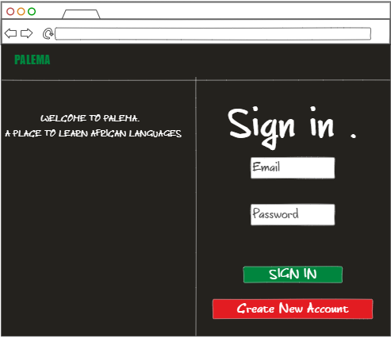

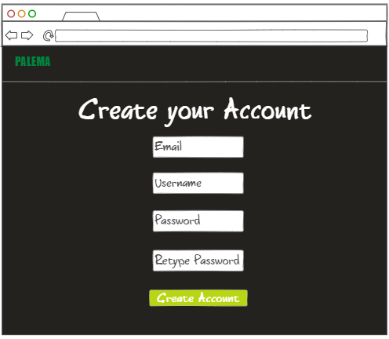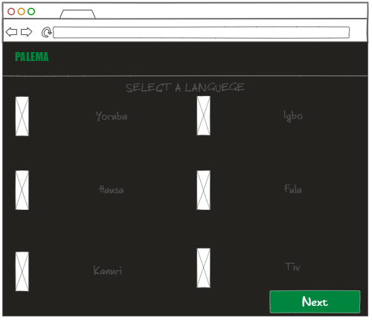

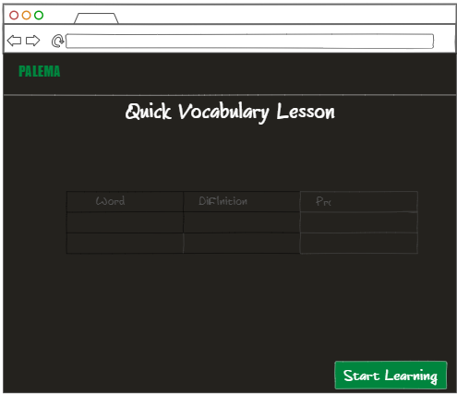

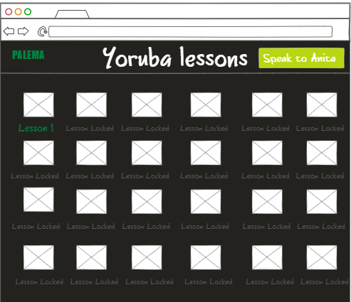

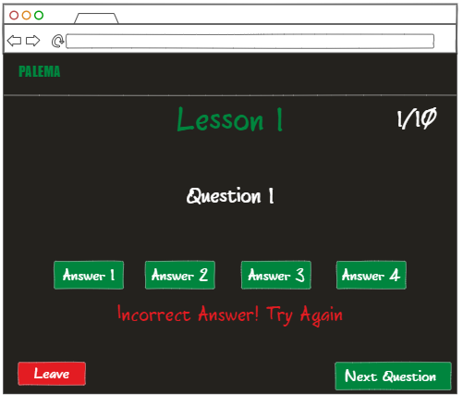

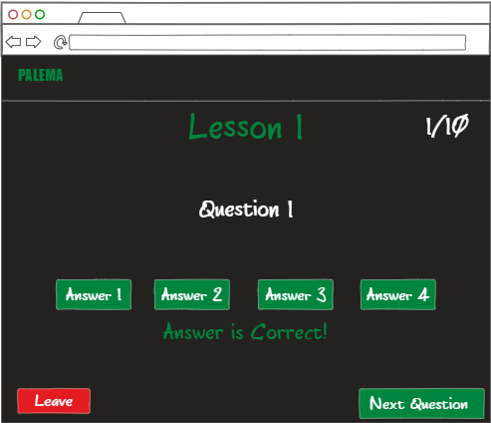

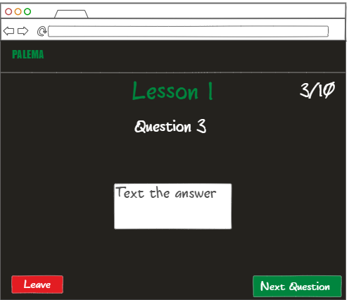

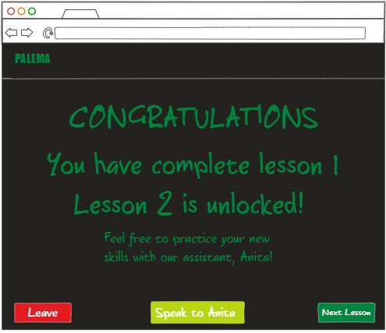

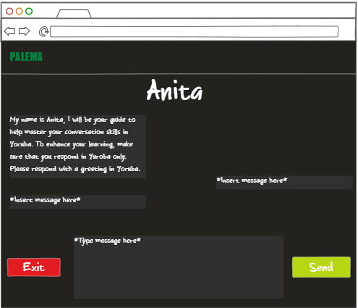

# Appendix B: Detailed Project Proposal

|  |  |
| --- | --- |
| First Name: | Daniel |
| Last Name: | Akiode |
| Student Number: | 1905423 |
| Supervisor: | Stewart Massie |

## Defining your Project

**1.1 Project title**

**Help:** a brief statement about what you are actually going to do.

|  |
| --- |
| Nigerian Tribal Language App  To create a Mobile-Based Web Application about teaching users Nigerian Tribal Languages using an AI to speak to the user in the Tribal Language. |

**1.2 Background**

**Help:** Provide the background to your project. This section should highlight the main topics in the area you are going to research. Essentially what is the project about, what has been done before and why is this project important? ~500 words

|  |
| --- |
| In this project, I am going to research about building an app that uses Artificial Intelligence(AI) and chatbot technology to teach users Nigerian Tribal Languages such as Yuroba, Igbo and Hausa. The reason why this project is important is because these Languages are not always taught to children living in the UK with Nigerian Heritage and there are not many good applications that can teach users the languages. For example, I have looked up apps that can teach Yuroba on google play and some of the apps do not really teach users the language but merely list Yuroba phrases and words which I do not find effective. The application I am planning to implement would teach the user how to have a conversation in Yuroba or other tribal Languages they choose. AI would be used to have a conversation with the user in the tribal language so that the user would be able to try their skills. The app would also provide lessons and activities to help users develop their skills.  AI is a type of technology that allows machine to learn from experience and perform tasks that can be done by a human being. Artificial Intelligence has been used predominantly in the modern world. Alexa for Amazon, Siri for apple, Google Assistant for Android/Google and Cortana for Microsoft use AI and chatbot technology. Android Application “SuperChinese” uses an AI to teach users Mandarin Chinese, similar to the type of app I want to build.  Chatbot is a type of artificial intelligence software that is used to allow computers to have a simulate conversation with the user using natural language by either text (Text Analysis) or voice (Speech Analysis). |

**1.3 Motivation**

**Help:** To whom is this project important? A project must address a question/problem that generates a small piece of new knowledge/solution. This new knowledge/solution must be important to a named group or to a specific client (such as a company, an academic audience, policy makers, people with disabilities) to make it worthwhile carrying out. This is the ***motivation*** for your project. In this section you should address who will benefit from your findings and how they will benefit. ~300 words

**Example** 1: If you intend to demonstrate that a mobile application that automates class registers at RGU will be more efficient than paper-based registers - the group who would be interested in knowing/applying these findings would be both academic and administrative staff at RGU and they would benefit by time saved and a reduction in their administrative workload.

**Example** 2: You are demonstrating that a particular 3D model design increases realism in 3D environments. The group that would be interested would be games designers or developers of 3D virtual environment applications. The would benefit from producing more realistic environments that could increase sales of their products.

**Example** 3: You have designed a new network topology for IrishOil plc’s new Aberdeen headquarters. The interested group would clearly be IrishOil. They would benefit from easier maintenance and improved security of their computer network.

|  |
| --- |
| The user group that would be interested in this project would be Nigerian Descendants who live in the UK and have never been taught their tribal language due to living in the UK all their life, often their parents did not bother teaching them. In building this application I can make the user group feel more motivated to learn to speak their tribal language. Teachers in Nigeria would benefit from this app as they could use it to teach students the tribal language of their choice. Its important for people to learn about their culture so that they can feel like they are part of the culture.  My intention is to demonstrate that a user can learn a new language through from a smartphone app. I would demonstrate that by building an AI that would interact with the user in the Language they have chosen to learn so that the user can then execute the skills they have learnt and then go out in the world an speak confidently in that language. The app would also include lessons and activities. |

**1.4 Aim & Objectives**

**Help:** Outline what are the main things your project is going to do and what steps or milestones will be used to achieve this aim. The Aim is unlikely to change throughout your project; however, the objectives are likely to adapt to your ongoing research and development. In particular it is highly likely that you may wish to split objectives into sub-objectives as work progresses. A good clear set of objectives give you something to evaluate your final project against.

**Example** : For the timetable app outlined above

Aim: To create a functioning attendance application that efficiently automates the taking of class registers.

Objective 1: study existing register system in place at RGU and identify weaknesses

Objective 2: research existing automation technology’s and identify and evaluate those that may be appropriate to taking in class registers

Objective 3: Implement chosen technologies to create prototype application

Objective 4: Conduct user trials to evaluate capabilities of prototype application

Objective 5: Create a refined application incorporating feedback from user trials

|  |
| --- |
| Aim: To create a Nigerian Tribal Language app with an Interactive AI component to support the identified user group to learn and improve their language skills.  Objective1: Study the Tribal Languages in order to understand the key challenges in learning the languages in UK environment  Objective2: Research how to create a web app that can support and motivate learning new languages by evaluating some of the existing application available on Google Play and Apple Store.  Objective3: Research how to implement AI and/or machine learning technologies in order to provide an effective application.  Objective:4 Create an AI Prototypes that supports chat bot functionality  Objective5: Develop the web application and integrate basic AI elements  Objective6: Test and evaluate the prototypes  Objective7: Create the final application incorporating all AI components into the web app.  Objective8 Evaluate the final Application. |

**1.5 Key Techniques**

**Help:** Perform some initial research into the area and outline what techniques you my research in further detail here. The techniques you cover here should include references to the papers where you have sourced the information. The techniques mentioned here are very likely to become the section headers in your literature review.

|  |
| --- |
| The skills that are required to create this application are to:   * Convert a website to a mobile application. The YouTube video below would demonstrate how to do so. * [**https://www.youtube.com/watch?v=Z0o3VodAiWU&ab_channel=LearnWithAliHossain**](https://www.youtube.com/watch?v=Z0o3VodAiWU&ab_channel=LearnWithAliHossain) * Design the interface of the application by using Ninjamock or Mockflow. * [**https://ninjamock.com/**](https://ninjamock.com/) * [**https://www.mockflow.com/**](https://www.mockflow.com/) * Create a chatbot using Tidio. * [**https://www.tidio.com/blog/how-to-create-a-chatbot-for-a-website/**](https://www.tidio.com/blog/how-to-create-a-chatbot-for-a-website/) * Use programming languages such as HTML, Python and Java to write the application. W3schools will be used as a source of information about how to write programming languages. * [**https://www.w3schools.com/**](https://www.w3schools.com/) |

**1.6 Legal, Social, Ethical, Professional and Security issues**

**Help:** Here you should discuss any legal, social, profession and security issues that you believe may occur during the course of your project. It is not acceptable to write none in this box, all projects, regardless of focus will have to address issues in one, or more, of these categories. This is an extremely important part of your honours project to which there is no correct answer, this section must be fully discussed with your Honours Supervisor.

**Example 1** : In the class register example above – there would be a Legal and Security issue with the gathering and storage of student data. There may be a social constraint as you may be relying on a user to have access to a specific technology. There will need to be consideration of user accessibility.

**Example 2** : A 3D model design may have ethical considerations in its evaluation. What if your model made users feel nauseous. Social constrains may again be access to technology or accessibility issues.

**Example 3** : You network design need to adhere to specific company policies. You would need to consider the possibility that your design could be wrong, compromising the company’s security.

|  |
| --- |
| * There would be legal and security issue when gathering user data for logging into their accounts. * Social Issues would occur when user don’t have the updated mobile version to run that app. * The information that I would display in the app may come out as incorrect. * Referencing the sources used for information would be required. * Copyright issues may occur when displaying media and information. |

**1.7 Project Plan**

**Help:** This is the project plan as to how you will go about achieving the objectives of the project.

**Example**: In the class register example above the research plan may involve:

Collecting and analysing paper-based registers in a given class on five occasions.

Identifying the error rate average on these occasions

Researching existing automation techniques

Designing and implementing a mobile application that automatically records attendance in class.

Deploying the application in the class on five occasions.

Identifying the error rate average of the mobile application on these occasions.

Comparison of data and summary of findings.

|  |
| --- |
| * Conducting a research on AI and web app techniques so that I can build confidence in creating the final product. – December 2020 * Design the Web application using NinjaMock/MockFlow to design the interface –Feb 2020 * Create various AI prototypes and implement the final product. – April 2020 * Evaluate the application by allowing people to test the app – April 2020 * Fix any errors that occurred during the evaluation - May 2020 |

**STUDENT PROJECT ETHICAL REVIEW (SPER) FORM**

**The aim of the University’s *Research Ethics Policy* is to establish and promote good ethical practice in the conduct of academic research. The questionnaire is intended to enable researchers to undertake an initial self-assessment of ethical issues in their research. Ethical conduct is not primarily a matter of following fixed rules; it depends on researchers developing a considered, flexible and thoughtful practice.**

**The questionnaire aims to engage researchers discursively with the ethical dimensions of their work and potential ethical issues, and the main focus of any subsequent review is not to ‘approve’ or ‘disapprove’ of a project but to make sure that this process has taken place.**

The *Research Ethics Policy* is available at  [www.intranet.rgu.ac.uk/credo/staff/page.cfm?pge=706](http://www.intranet.rgu.ac.uk/credo/staff/page.cfm?pge=7060)0

|  |  |
| --- | --- |
| **Student Name** | Daniel Akiode |
| **Supervisor** | Stewart Massie |
| **Project Title** | Nigerian Tribal Language Web App with AI |
| **Course of Study** | BSc Honours Computing(Application Software Development) |
| **School/Department** | School of Computing |

|  |  |  |  |
| --- | --- | --- | --- |
| **Part 1 : Descriptive Questions** | | | |
| 1 | Does the research involve, or does information in the research relate to: | Yes | No |
|  | (a) individual human subjects | x |  |
| (b) groups (e.g. families, communities, crowds) |  | x |
| (c) organisations |  | X |
| (d) animals? |  | X |
| Please provide further details: | | |
|  | The research is for anyone who want to learn Nigerian Dialect, and during the project a small number of potential users will be asked to evaluate the application. However, personal data will not be collected. |  |  |
| 2 | Will the research deal with information which is private or confidential? | Yes | No |
|  |  | x |
| Please provide further details: | | |
|  |  |  |

|  |  |  |  |
| --- | --- | --- | --- |
| Part 2: The Impact of the Research | | | |
| 3 | In the process of doing the research, is there any potential for harm to be done to, or costs to be imposed on | Yes | No |
|  | (a) research participants? |  | x |
| (b) research subjects? |  | x |
| (c) you, as the researcher? |  | x |
| (d) third parties? |  | x |
| Please state what you believe are the implications of the research: | | |
|  | | |
| 4 | When the research is complete, could negative consequences follow: | Yes | No |
|  | (a) for research subjects |  | x |
| (b) or elsewhere? |  | x |
| Please state what you believe are the consequences of the research: | | |
|  | | |

|  |  |  |  |
| --- | --- | --- | --- |
| Part 3: Ethical Procedures | | | |
| 5 | Does the research require informed consent or approval from: | Yes | No |
|  | (a) research participants? |  | x |
| (b) research subjects |  | x |
| (c) external bodies |  | x |
| If you answered yes to any of the above, please explain your answer: | | |
| 6 | Are there reasons why research subjects may need safeguards or protection? | Yes | No |
|  |  | X |
| If you answered yes to the above, please state the reasons and indicate the measures to be |  |  |
| 7 | Has PVG membership status been considered? |  |  |
|  | (a) PVG membership is not required. | x |  |
| (b) PVG membership is required for working with children. |  | x |
| (c) PVG membership is required for working with protected adults. |  | x |
| (d) PVG membership is required for working with both children and protected |  | x |
| If you answered yes to (b), (c) or (d) above, please give details: | | |
| 8 | Are specified procedures or safeguards required for recording, management, or storage of data? | Yes | No |
|  |  | x |
| If you answered yes to the above, please outline the likely undertakings: | | |

|  |  |  |  |
| --- | --- | --- | --- |
| Part 4: The Research Relationship | | | |
| 9 | Does the research require you to give or make undertakings to research participants or subjects about the use of data? | Yes | No |
|  |  | x |
| If you answered yes to the above, please outline the likely undertakings: | | |
| 10 | Is the research likely to be affected by the relationship with a sponsor, funder or employer? | Yes | No |
|  |  | x |
| If you answered yes to the above, please identify how the research may be affected: | | |

|  |  |  |  |
| --- | --- | --- | --- |
| Part 5: Other Issues | | | |
| 11 | Are there any other ethical issues not covered by this form which you believe you should raise? | Yes | No |
|  |  | x |
|  |  | | |

|  |  |  |  |
| --- | --- | --- | --- |
| Statement by Student  I believe that the information I have given in this form is correct, and that I have addressed the ethical issues as fully as possible at this stage. | | | |
| Signature | D.Akiode | Date | 05/10/2020 |

**If any ethical issues arise during the course of the research, students should complete a further Student Project Ethical Review (SPER) form.**

The *Research Ethics Policy* is available at  [www.intranet.rgu.ac.uk/credo/staff/page.cfm?pge=706](http://www.intranet.rgu.ac.uk/credo/staff/page.cfm?pge=7060)0

|  |  |  |  |  |
| --- | --- | --- | --- | --- |
| Part 6: To be completed by the supervisor | | | | |
| 12 | Does the research have potentially negative implications for the University? | | Yes | No |
|  |  | X |
| If you answered yes to the above, please explain your answer: | | | |
|  | | | |
| 13 | Are any potential conflicts of interest likely to arise in the course of the research? | | Yes | **No**  **X** |
|  | If you answered yes to the above, please identify the potential conflicts: | | | |
|  | | | |
| 14 | Are you satisfied that the student has engaged adequately with the ethical implications of the work? [In signifying agreement, supervisors are accepting part of the ethical responsibility for the project] | | **Yes**  **X** | No |
|  | If you answered no to the above, please identify the potential issues: | | | |
|  | | | |
| 15 | **Appraisal:** Please select one of the following | | | |
|  | The research project should proceed in its present form – no further action is required | | X | |
| The research project requires ethical approval by the School Ethics Review Panel | |  | |
| The research project needs to be returned to the student for modification prior to further action | |  | |
| The research project requires ethical review by an external body. If this applies please give details | |  | |
| Title of External Body providing ethical review |  | | |
| Address of External Body |  | | |
| Anticipated date when External Body may consider project |  | | |

|  |  |  |  |
| --- | --- | --- | --- |
| Affirmation by Supervisor | | | |
| **I have read the student’s responses and have discussed ethical issues arising with the student. I can confirm that, to the best of my understanding, the information presented by the student is correct and appropriate to allow an informed judgement on whether further ethical approval is required.** | | | |
| **Signature** | Stewart Massie | **Date** | 16/10/2020 |

# Appendix C: Acceptance test table

|  |  |  |  |
| --- | --- | --- | --- |
| No. | Requirement | Result | Requirement met? |
| 1 | Web Application must contain chatbot | Web application Contains chatbot | Yes |
| 1 | Chatbot must communicate with the user in the language chosen by the user so that the user can practice the targeted language. | Chatbot communicates with the user in the only in the chosen language via text only. User can speak to the chatbot after they have completed the lessons. | Yes |
| 2. | Must teach the user at least one language. | So far, the application only teaches one Nigerian Language (Yoruba) due to limited time. The application contains lessons which can also be quizzes. So far, the application only has 2 lessons, lesson 1 with 10 questions and lessons lesson 2 with 5 questions. The lessons so far only teach basic greetings, but more topics can easily be added. | Yes |
| 3. | All users should register and create an account in order to use the application so that they can save their progress. | A login system is yet to be implemented in the application. | No |
| 4. | Lessons should be more difficult than the previous lessons so that there is challenge for the user. | Lesson 2 contains harder questions then lesson one. | Yes |
| 5. | Should display an “about” page so that the user can have some clarity about how the website works. | About page not implemented | No |
| 6. | Should contain 2 types of users: Admin User and Learning User | There are no user accounts as there is no login system | No |
| 7. | Could Allow users to log-in via other account such as Facebook, Twitter, Google etc. | Users cannot log in via Google, Facebook o twitter as there is no login system | No |
| 8. | Could allow users to communicate so that they can help/compete against each other. | Application does not allow users to communicate each other, yet. | No |
| 9. | Could provide games/ activities for users to provide entertainment and motive for the user to use the application again. | There may not be any games but the quizzes in the lessons count as an activity. | yes |
| 10. | Web Application must use a Web Server. | React provides the web server. | Yes |

# Appendix D: Chatbot System Test

|  |  |  |  |  |
| --- | --- | --- | --- | --- |
| Case No. | Input | Expected Result | Actual Output | Comment |
| 1. | E ka ro | Ekaro!, So Wa dada? | Ekaro!, So Wa dada? | Works as expected |
| 2. | Ekaro | Ekaro!, So Wa dada? | Ekaro!, So Wa dada? | Works as expected |
| 3. | Kilo Ruko E | Oruko MiNi Anita | Oruko MiNi Anita | Works as expected |
| 4. | Hi my name is Daniel | Shows Nothing | Shows nothing Nothing | Works as expected |
| 5. | 12345 | Show nothing | Show nothing | Works as expected |
| 6. | K | Show nothing | Shows everything that has a k | Tried adding {userInput.length <= 3? null: <h3>{val.chatbot}</h3>} in <div> tag |
| 7. | K | Show nothing | Shows everything that has a k | Tried using if(userInput =="" || userInput.length <= 3) {  return null in filter() function. |
| 8. | K | Show nothing | Shows nothing | Bug fixed |
| 9. | aakadb | Show nothing | Shows nothing | Works as expected |
| 10. | E ka | Show nothing | Shows two messages “E ka ro ” and “E ka san” | Removed /include function and added (val.user.toLowerCase() === **userInput.toLowerCase()** |
| 11. | E ka | Show nothing | Show nothing | Works as expected |
| 12. | E kule | E ka bo! Bawo ni ọjọ rẹ | E ka bo! Bawo ni ọjọ rẹ | Works as expected |
| 13. | kilo ruko e | Oruko MiNi Anita | Oruko MiNi Anita | Works as expected |
| 14. | inu mi dun lati moe | Inu mi dun lati pade yin, Bawo ni ọjọ rẹ ṣe | Inu mi dun lati pade yin, Bawo ni ọjọ rẹ ṣe | Works as expected |

# References

Admin, .., 2020. *Mondly Review: It’S Quick, Easy And Free To Learn A New Language*. [online] Bestlaptopguides.com. Available at: <https://bestlaptopguides.com/mondly-review-its-quick-easy-and-free-to-learn-language/#tab-con-4> [Accessed 19 November 2020].

Black Student Center, 2021. *Pan-African Flag | Black Student Center | CSUSM*. [online] Csusm.edu. Available at: <https://www.csusm.edu/bsc/pan-afflag.html#:~:text=Red%3A%20the%20blood%20that%20unites,wealth%20of%20Africa%2C%20the%20Motherland.> [Accessed 25 April 2021].

BLOG.VSOFTCONSULTING.COM, B., 2020. *7 of the Best Language-Learning Chatbot Apps*. [online]. Blog.vsoftconsulting.com. Available from: https://blog.vsoftconsulting.com/blog/7-of-the-best-language-learning-chatbot-apps [Accessed 27 November 2020].

BAHOOSH, T., 2020. *This unique app offers a new way to learn languages*. [online]. Reviewed Lifestyle. Available from: https://www.reviewed.com/lifestyle/features/mondly-review-language-app-has-unique-edge [Accessed 14 November 2020].

Boyle, M., 2020. *Mobile Internet Statistics - 2020 | Finder UK*. [online] Finder UK. Available at: <https://www.finder.com/uk/mobile-internet-statistics#:~:text=Research%20suggests%2084%25%20of%20UK,own%20a%20smartphone%20in%202020.&text=Those%20aged%2016%2D24%20were,out%20of%20any%20age%20group.> [Accessed 11 November 2020].

BLOG, M., 2015. *4 Ways to Approach Learning a Foreign Language - RWS*. [online]. RWS. Available from: https://www.rws.com/insights/rws-moravia-blog/4-ways-to-approach-learning-a-foreign-language/# [Accessed 15 November 2020].

BLOGS, V., 2020. *12 Best Software Development Methodologies with Pros & Cons*. [online]. Web Solutions Blog. Available from: https://acodez.in/12-best-software-development-methodologies-pros-cons/#Agile_Software_Development_Methodology [Accessed 25 November 2020].

CEASAR, J., 2020. *Mondly uses cutting-edge technology like chatbots and augmented reality to create a more immersive language-learning experience — but not all of the features work smoothly*. [online]. Business Insider. Available from: https://www.businessinsider.com/mondly-language-learning-overview?r=US&IR=T#how-mondly-works [Accessed 14 November 2020].

Chamberlin, V., 2020. *A protester stands listening to speakers and holding a Pan-African flag in Lincoln Park*. [image] Available at: <ibw21, 2015. activist-pan-african-flag-chicago-2015. [image] Available at: <https://ibw21.org/commentary/to-honor-king-lets-work-to-end-racial-capitalism/attachment/activist-pan-african-flag-chicago-2015/> [Accessed 25 April 2021].> [Accessed 25 April 2021].

Currey, J., 1998. *UNESCO General History of Africa, Vol. VI, Abridged Edition*. [online] Google Books. Available at: <https://books.google.co.uk/books?id=VC7kKcXdDhkC&pg=PA305&redir_esc=y#v=onepage&q&f=false> [Accessed 25 April 2021].

Deyi, S., 2021. *The importance of African languages • Voices360*. [online] Voices360. Available at: <https://www.voices360.com/community-development/the-importance-of-african-languages> [Accessed 2 April 2021].

D., S., 2020. *10 Tried, Tested and Trusted Language Teaching Approaches | General Educator Blog*. [online]. Fluentu.com. Available from: https://www.fluentu.com/blog/educator/language-teaching-approaches/ [Accessed 15 November 2020].

D., S. and CRISTIANO, M., 2020. *Memrise vs Duolingo: Which of These Popular Language Learning Programs Is Right for You?*. [online]. FluentU Language Learning. Available from: https://www.fluentu.com/blog/memrise-vs-duolingo/ [Accessed 17 November 2020].

ENFROY, A., 2020. *12 Best Database Software and Systems of 2020 (Ultimate Guide)*. [online]. Adam Enfroy. Available from: https://www.adamenfroy.com/database-software#:~:text=SQLite%2C%20and%20SAP.-,What%20is%20Database%20Software%3F,fields%2C%20columns%2C%20and%20tables. [Accessed 25 November 2020].

Gafni, R., Biran Achituv, D. and Joyce Rachmani, G., 2017. *LEARNING FOREIGN LANGUAGES USING MOBILE APPLICATIONS*. 16th ed. [ebook] Tel Aviv. Available at: <http://jite.informingscience.org/documents/Vol16/JITEv16ResearchP301-317Gafni3476.pdf> [Accessed 11 November 2020].

GEEKS, G., 2020. *Top 10 Frameworks for Web Applications - GeeksforGeeks*. [online]. GeeksforGeeks. Available from: https://www.geeksforgeeks.org/top-10-frameworks-for-web-applications/ [Accessed 24 November 2020].

Gibson, A., 2020. *Why I’m Learning West African Languages… And You Should, Too! | Joy of Languages*. [online] Joyoflanguages. Available at: <http://joyoflanguages.com/learn-west-african-languages/> [Accessed 2 April 2021].

GOODFIRMS, G., 2020. *What is Software Deployment?*. [online]. GoodFirms Glossary - GoodFirms. Available from: https://www.goodfirms.co/glossary/software-deployment/ [Accessed 25 November 2020].

GUARNERA, A., 2018. *Five Approaches to Teaching Foreign Languages — Language Learning At Home*. [online]. Language Learning At Home. Available from: https://languagelearningathome.com/blog/2018/4/28/five-approaches-to-teaching-foreign-languages [Accessed 15 November 2020].

HAZEVYTCH, L. and VILCHYNSKA, H., 2020. *Agile Advantages for Software Development and Your Business*. image. [online]. Available from: https://devcom.com/tech-blog/agile-advantages-for-business/ [Accessed 25 November 2020].

ibw21, 2015. *activist-pan-african-flag-chicago-2015*. [image] Available at: <https://ibw21.org/commentary/to-honor-king-lets-work-to-end-racial-capitalism/attachment/activist-pan-african-flag-chicago-2015/> [Accessed 25 April 2021].

KENT, K., 2017. *Memrise App Review | Learn to Language*. [online]. Learn To Language. Available from: http://learntolanguage.com/memrise-app-review/ [Accessed 26 November 2020].

KISSFLOW, K., 2020. *Rapid Application Development (RAD) | Definition, Steps and Benefits*. [online]. Kissflow. Available from: https://kissflow.com/rad/rapid-application-development/ [Accessed 25 November 2020].

Kukulska-Hulme, A., 2020. *The Encyclopedia Of Applied Linguistics Mobile‐Assisted Language Learning*. [ebook] Wiley Online Library, p.1. Available at: <https://onlinelibrary.wiley.com/doi/abs/10.1002/9781405198431.wbeal0768.pub2> [Accessed 11 November 2020].

MDN WEB DOCS, M., 2020. *Introduction to the server side*. [online]. MDN Web Docs. Available from: https://developer.mozilla.org/en-US/docs/Learn/Server-side/First_steps/Introduction [Accessed 24 November 2020].

PAJAK, B. and TSAI, K., 2020. *How we’ve improved the Duolingo learning experience this year (and a sneak peek toward 2020!)*. [online]. Duolingo Blog. Available from: https://blog.duolingo.com/how-weve-improved-the-duolingo-learning-experience-this-year-and-a-sneak-peek-toward-2020/ [Accessed 13 November 2020].

PAPADOPOULOU, P., 2014. *Duolingo Review - Learn That Language Now*. [online]. Learn That Language Now. Available from: http://learnthatlanguagenow.com/language-product-reviews/duolingo-review/ [Accessed 17 November 2020].

RAVENSCRAFT, E., 2019. *500 Days of Duolingo: What You Can (and Can’t) Learn From a Language App (Published 2019)*. [online]. Nytimes.com. Available from: https://www.nytimes.com/2019/05/04/smarter-living/500-days-of-duolingo-what-you-can-and-cant-learn-from-a-language-app.html [Accessed 13 November 2020].

RESEARCH GATE, 2020. image. [online]. Available from: https://www.researchgate.net/figure/The-interface-of-Duolingo-web-application-The-user-interface-of-Duolingo-web-application_fig1_301822377 [Accessed 13 November 2020].

*Review of the Language Learning App "Duolingo" – Specialist Language Courses*, 2020. [online]. Available from: https://specialistlanguagecourses.com/review-language-learning-app-duolingo/ [Accessed 14 November 2020].

SANTOS, J., 2020. *3 Best Tools for Waterfall Project Management*. [online]. Project-Management.com. Available from: https://project-management.com/3-best-tools-for-waterfall-project-management/ [Accessed 25 November 2020].

SHEWAN, D., 2020. *10 of the Most Innovative Chatbots on the Web*. [online]. Wordstream.com. Available from: https://www.wordstream.com/blog/ws/2017/10/04/chatbots [Accessed 13 November 2020].

SINGH, A., 2019. *What Is Rapid Application Development (RAD)?*. [online]. Blog.capterra.com. Available from: https://blog.capterra.com/what-is-rapid-application-development/ [Accessed 25 November 2020].

SIRK, C., 2020. *Memrise: A Language Learning App Built on Mnemonics*. [online]. CRM.org. Available from: https://crm.org/news/memrise-a-language-learning-app-built-on-mnemonics [Accessed 14 November 2020].

SPECTRA SPEAKS, S., 2013. *What Kind of African Doesn't Speak Any African Languages? Me. | African Arguments*. [online]. African Arguments. Available from: https://africanarguments.org/2013/04/08/what-kind-of-african-doesnt-speak-any-african-languages-me/ [Accessed 27 November 2020].

TEAM, S., 2017. *Top 4 software development methodologies | Synopsys*. [online]. Software Integrity Blog. Available from: https://www.synopsys.com/blogs/software-security/top-4-software-development-methodologies/ [Accessed 25 November 2020].

TECHTERMS, T., 2013. *Framework Definition*. [online]. Techterms.com. Available from: https://techterms.com/definition/framework#:~:text=A%20framework%2C%20or%20software%20framework,programs%20for%20a%20specific%20platform.&text=A%20framework%20may%20also%20include,in%20the%20software%20development%20process. [Accessed 24 November 2020].

THOMPSON, A., 2020. *Lingvist vs Duolingo 2020: Which One Is The Best? (Pros & Cons)*. [online]. Bloggers Ideas. Available from: https://www.bloggersideas.com/lingvist-vs-duolingo/ [Accessed 17 November 2020].

Translators Associations Africa, T., 2021. *Africa: The most multilingual continent in the world has few translators associations*. [online] Lexis. Available at: <https://www.lexis.pro/news/africa/africa-the-most-multilingual-continent-in-the-world-has-few-translators-associations-1398/#:~:text=Translators%20Associations%20Africa-,Africa%3A%20The%20most%20multilingual%20continent%20in%20the%20world%20has%20few,%2Dpopulous%20continent%2C%20after%20Asia.&text=UNESCO%20has%20estimated%20that%20around%20two%20thousand%20languages%20are%20spoken%20in%20Africa.> [Accessed 2 April 2021].

WEINSTEIN, J., 2020. *Client-Side vs Server-Side: What's The Difference? | Career Karma*. [online]. Career Karma. Available from: https://careerkarma.com/blog/client-vs-server-side-development/ [Accessed 24 November 2020].